**University of Maryland, Baltimore County**

**MPS in Data Science**

**Data 606: Capstone in Data Science**

**Professor: Jester Ugalde**

**May 14, 2024**

**Project**

**Traffic Sign Recognition**

**By**

**Team 6**

Ashritha Korukanti

Shashank Koya

Lakshminivas Reddy

Naga Rekha Harini Kodati

Sohail Shaik

**ABSTRACT**

Traffic Sign Recognition (TSR) is vital for the advancement of autonomous driving technologies and Advanced Driver-Assistance Systems (ADAS), enhancing vehicle navigation and safety. Real-time traffic sign detection, which involves identifying the precise location of traffic signs within natural scenes, represents a critical and complex challenge within the field of computer vision. It holds substantial industrial significance as numerous algorithms have been introduced, and advanced driver assistance systems that include traffic sign detection and recognition capabilities are now commercially available. Despite the many competing approaches, there is no clear consensus on what the state-of-the-art in this field is. This can be accounted to the lack of comprehensive, unbiased comparisons of those methods. We are aiming to close this gap by our project "Traffic Sign recognition". This project employs the You Only Look Once (YOLO) version 8, an advanced deep learning framework, to recognize and classify traffic signs in real-time. The project identifies future research opportunities, including the integration of TSR with other sensory technologies, to further refine the safety and efficacy of autonomous navigational systems. This study establishes a strong foundation for using YOLOv8 in TSR, contributing to safer and more effective autonomous driving solutions.

**INTRODUCTION**

Road Traffic Accidents (RTA) are among the leading causes of damage, injuries, or deaths worldwide. These accidents are events that occur on roads and highways involving vehicles. They can be attributed to various factors, including human error, environmental conditions, technical malfunctions, or a combination of these. Across the world, traffic accidents cause major health problems and are of concern to health institutions, with nearly 1.35 million people killed or disabled in traffic accidents every year. Approximately 3700 people die every day in fatal accidents alone (Ahmed et al., 2023). Furthermore, the World Health Organization (WHO) indicates that diseases generated by traffic accidents ranked eighth in the world in 2018, accounting for 2.5% of all deaths worldwide. Based on data from 2015, the WHO also estimates that around 1.25 million deaths may occur annually (Ahmed et al., 2023).

In the United States, approximately 12.15 million vehicles were involved in crashes in 2019. The number of road accidents per one million inhabitants in this country is forecast to dip down in the next few years, reaching just over 7100 in 2025 (Ahmed et al., 2023). In Europe, between 2010 and 2020, the number of road deaths decreased by 36%. Compared to 2019, when there were 22,800 fatalities, 4000 fewer people lost their lives on EU roads in 2020 (Ahmed et al., 2023).

Many studies have focused on traffic safety, including traffic accident analysis, vehicle collision detection, collision risk warning, and collision prevention (Ahmed et al., 2023). In addition, several intelligent systems have been proposed that specialize in traffic sign detection and recognition using computer vision (CV) and deep learning (DL) (Flores-Calero et al., 2024).

As autonomous and semi-autonomous vehicles increasingly integrate into mainstream traffic, the necessity for advanced Traffic Sign Recognition (TSR) systems becomes paramount. These systems are critical components of both autonomous vehicles and Advanced Driver-Assistance Systems (ADAS), responsible for the accurate detection and interpretation of traffic signs (Flores-Calero et al., 2024).

This project employs the advanced You Only Look Once (YOLO) version 8 object detection model to address the TSR challenge, leveraging its capability to process images quickly and accurately—a necessity for real-time applications (Mehra, 2023). YOLOv8 stands out by evaluating the entire image in a single pass, predicting multiple bounding boxes and class probabilities efficiently, thus reducing processing time while enhancing accuracy (Boesch, 2024).

The focus of this research is to improve the reliability and effectiveness of TSR across diverse conditions such as variable lighting, different weather scenarios, and partial obstructions. By utilizing real-time images of traffic signs which reflect these varying conditions, the project evaluates YOLOv8's performance in identifying and classifying traffic signs (Flores-Calero et al., 2024).

The successful application of YOLOv8 in TSR could significantly enhance the operational safety of autonomous driving systems, marking a substantial advancement in autonomous vehicle technologies and traffic management systems.

**YOLOv8:**

You Only Look Once (YOLO) is a revolutionary object-detection framework first introduced in a 2015 research paper by Joseph Redmon, Santosh Divvala, Ross Girshick, and Ali Farhadi. YOLO marked a significant advancement in the realm of real-time object detection, outperforming its precursor, the Region-based Convolutional Neural Network (R-CNN). Operating as a single-shot detector, YOLO uniquely classifies and locates objects in one swift operation by using a single neural network that predicts bounding boxes and class probabilities from the entire image at once. The YOLO framework has been continually refined and expanded, leading to multiple versions developed by various research teams, with the latest version being YOLOv8. This network simultaneously determines bounding boxes and class probabilities for every detected object within an image. The most recent iteration, YOLOv8, surpasses its predecessors by incorporating several enhancements such as spatial attention mechanisms, feature fusion, and context aggregation modules. These advancements lead to quicker and more precise object detection, establishing YOLOv8 as a crucial algorithm in the object detection domain.

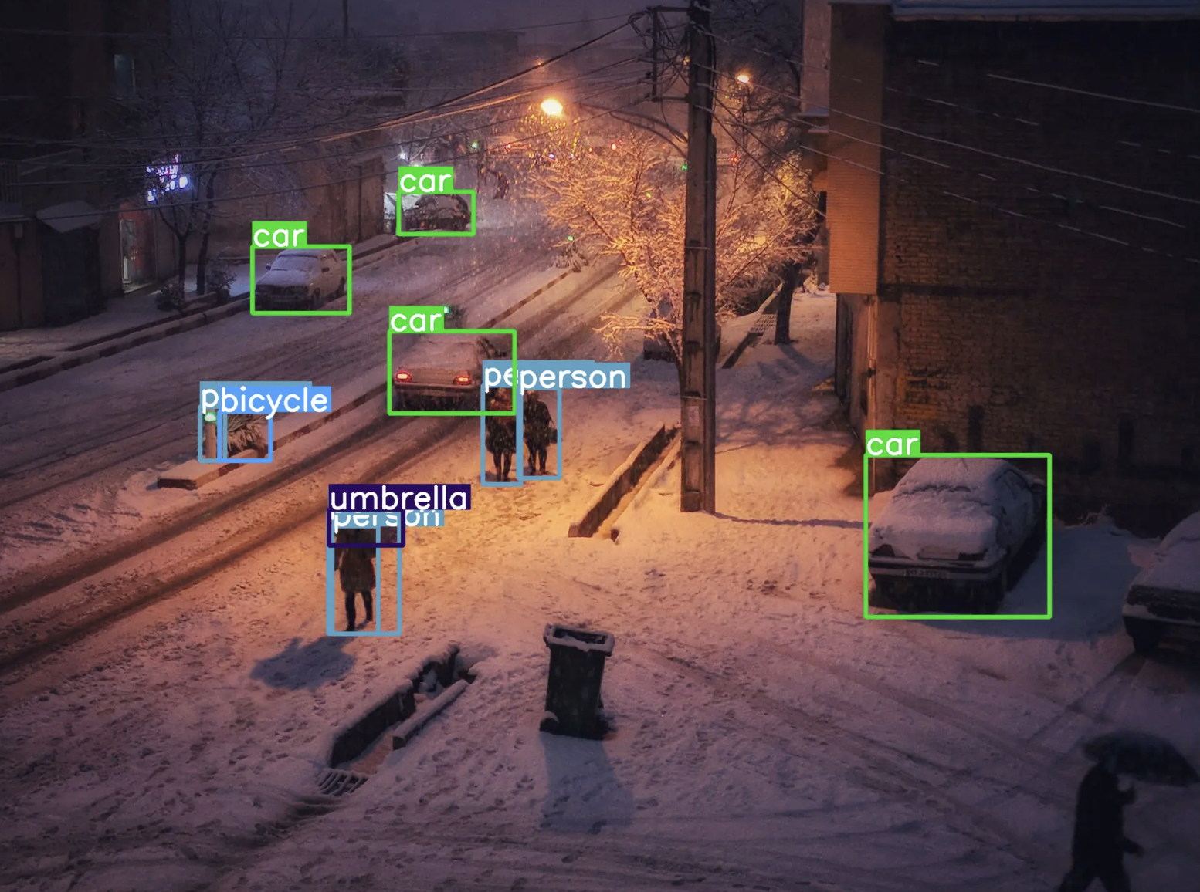

**Figure:** Object Detection using YOLOv8

**ARCHITECTURE OF YOLO:**

The architecture of this model is divided into three primary components: the backbone, neck, and head. The backbone is typically a pre-trained Convolutional Neural Network (CNN) that processes the input image to generate feature maps at various levels—low, medium, and high. These feature maps are then integrated in the neck using path aggregation mechanisms such as the Feature Pyramid Network (FPN), which effectively combines these disparate features into a coherent set. Finally, the head, which may utilize either a one-stage or dense prediction model like YOLO or Single-shot Detector (SSD), or a two-stage or sparse prediction model like those in the R-CNN family, is responsible for the actual tasks of object classification and bounding box prediction.

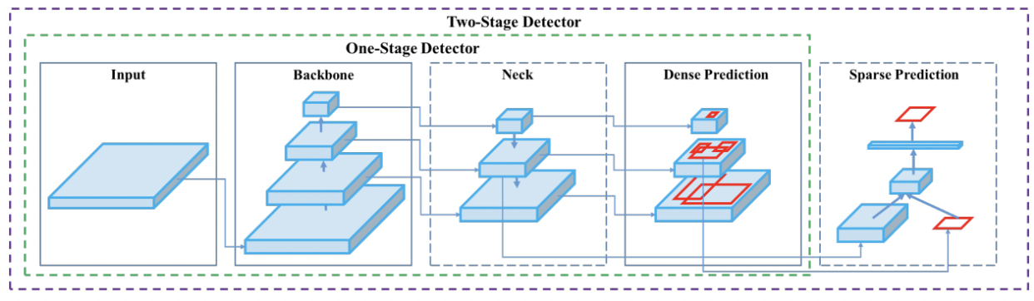

**Figure:** essential mechanics of an object detection model.

Ultralytics YOLOv8, the latest YOLO version released in January 2023. YOLOv8(medium) has a 50.2 mAP score at 1.83 milliseconds on the COCO dataset and A100 TensorRT. YOLO v8 also features a Python package and CLI-based implementation, making it easy to use and develop. YOLOv8 comes in five variants based on the number of parameters – nano(n), small(s), medium(m), large(l), and extra-large(x). We can use all the variants for classification, object detection, and segmentation.

**Features of YOLOv8:**

The main features of YOLOv8 include mosaic data augmentation, anchor-free detection, a C2f module, a decoupled head, and a modified loss function.

1. Mosaic data augmentation: YOLOv8 employs mosaic data augmentation, which blends four separate images to give the model enhanced contextual insights. The key update in YOLOv8 is that this augmentation method is discontinued in the final ten epochs of training to enhance overall performance.
2. Anchor-free detection: YOLOv8 has transitioned to an anchor-free detection method to boost its generalization capabilities. The issue with anchor-based detection is that it relies on predefined anchor boxes, which can slow down the learning process for specialized datasets. In contrast, anchor-free detection allows the model to predict the center point of an object directly and diminishes the quantity of bounding box predictions required. This adjustment streamlines the Non-max Suppression (NMS) process, an essential pre-processing step that eliminates inaccurate predictions.

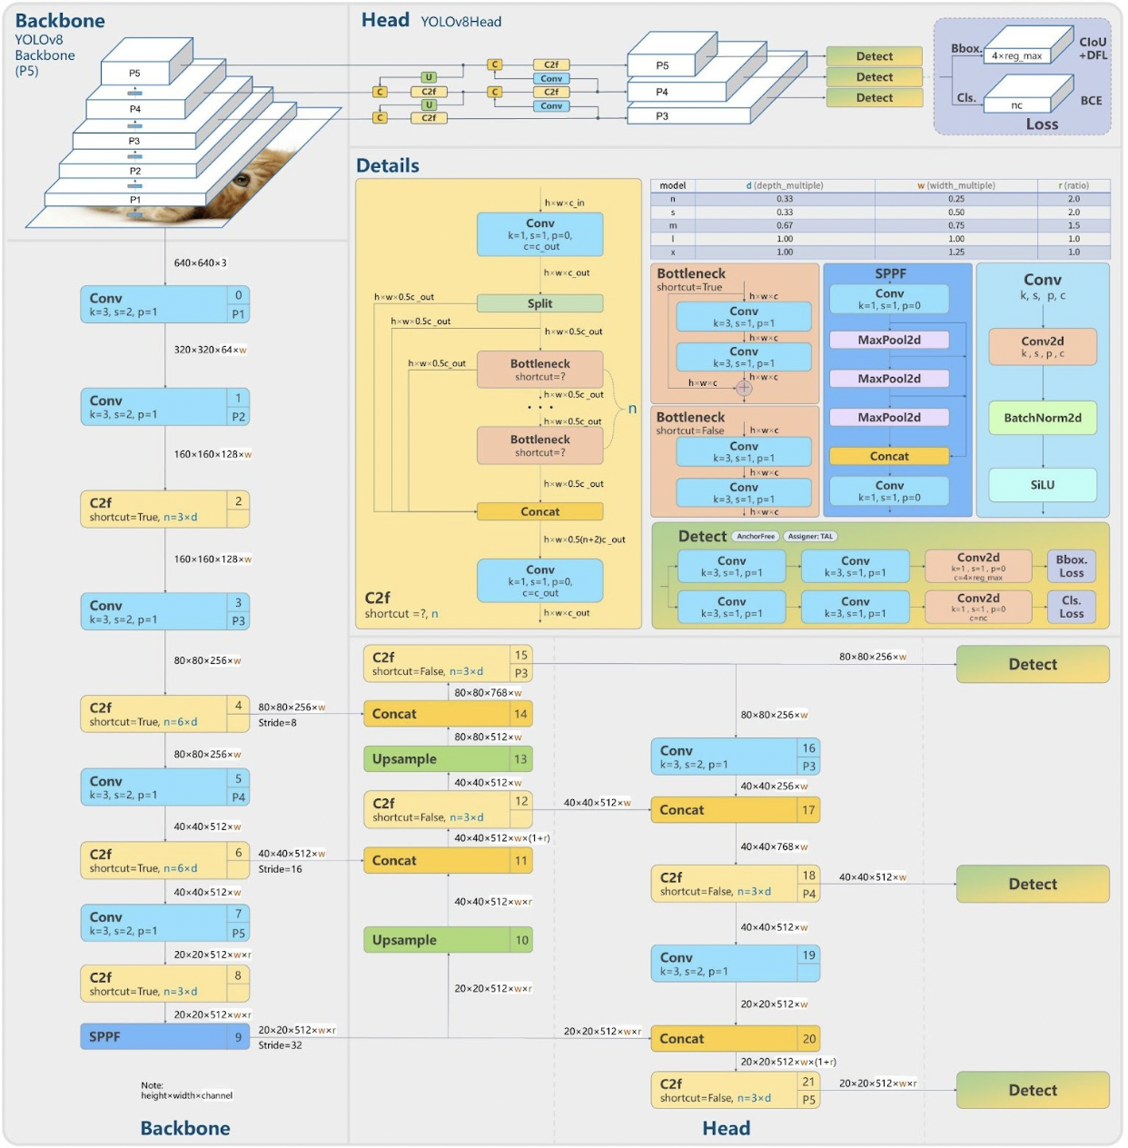**Figure:** Architecture of YOLO

1. C2f module: The backbone of the model has been updated from a C3 module to a C2f module. The key distinction between these two is that the C2f module aggregates the outputs from all bottleneck modules, whereas the C3 module utilizes only the output from the final bottleneck module. Bottleneck modules, composed of bottleneck residual blocks, are designed to lower computational demands within deep learning networks. This enhancement accelerates the training phase and enhances the flow of gradients throughout the network.
2. Decoupled Head: The diagram above illustrates that the head no longer performs classification and regression together. Instead, it performs the tasks separately, which increases model performance.
3. Loss: Due to the decoupled head separating classification and regression tasks, there's a risk of misalignment in the model, where it may accurately locate one object but misclassify it as another. To address this, the model uses an alignment score to identify the top-k positive samples. It then calculates the classification loss with Binary Cross-Entropy (BCE) and the regression loss using Complete Intersection over Union (CIoU) and Distributional Focal Loss (DFL). The BCE loss quantifies the discrepancy between the actual and predicted labels.

**Implementation Efficiency**

YOLOv8 is not just about architectural and training improvements; it also focuses on implementation efficiency:

**Model Pruning and Quantization:** Techniques like pruning and quantization are applied to reduce the model size without significantly impacting its performance. This makes YOLOv8 suitable for deployment on edge devices used in autonomous vehicles.

Parallel Processing: The model can process images in batches, utilizing GPU acceleration to handle multiple images simultaneously. This capability is essential for real-time TSR, where processing speed is a critical requirement.

**Performance Metrics**

In the context of TSR, YOLOv8's performance is evaluated using several key metrics:

1. Precision and Recall: These metrics assess the accuracy of the detections and the model's ability to capture all relevant instances.
2. Mean Average Precision (mAP): This is a comprehensive metric that evaluates precision at different recall levels, providing an overall effectiveness score of the model in detecting traffic signs under varied conditions.
3. Intersection over Union (IoU): IoU measures the overlap between predicted and actual bounding boxes, with higher values indicating better accuracy in localizing traffic signs.

**Integration with Autonomous Systems**

The integration of YOLOv8 into autonomous driving systems involves several steps:

**Sensor Fusion:** YOLOv8's predictions can be combined with data from other sensors, such as radar and LiDAR, to enhance detection accuracy and reliability.

**Real-time Decision Making:** The fast processing speeds of YOLOv8 allow it to feed into the decision-making modules of autonomous vehicles, enabling real-time responses to traffic sign commands.

**Data Set:**

For our project “Traffic Sign Detection” we have considered wide variety of real time traffic signs. These images vary not only in the type of signs they display but also in the conditions under which they were captured—ranging from bright daylight to dimly lit scenarios, and from clear to obstructed views. This diversity is crucial for training a model that can perform well across different real-world conditions. The dataset is sourced from public repositories that provide images labeled with the type of traffic sign, which are essential for supervised learning tasks like this one.

**Preprocessing and Augmentation:**

The preprocessing steps for this dataset involve reading images from the directory and applying several transformations to make them suitable for feeding into the YOLOv8 model. Key preprocessing tasks likely include:

Resizing Images: To match the input size requirement of the model (416x416 pixels), which ensures that the network receives uniformly sized inputs.

Normalization: To scale pixel values to a common range, typically [0,1], which helps in speeding up the convergence during training by providing a consistent scale of data.

Data Augmentation: Techniques like random cropping, rotation, and horizontal flipping are possibly employed to artificially expand the dataset. This not only helps in making the model robust to various orientations and positions of traffic signs but also aids in preventing overfitting by providing a richer set of training examples.

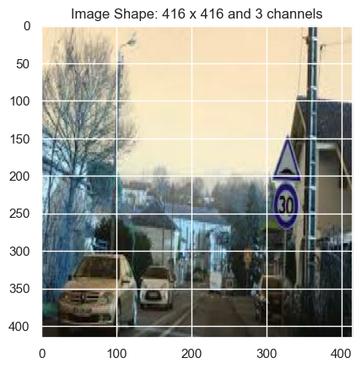

**FIGURE**: displaying shape of the image

**Analysis and Methodology**

**Model Setup and Training:**

YOLOv8 Integration: The project utilizes the YOLO("yolov8n.pt") instantiation, indicating the use of a pre-trained YOLOv8 model. This model is advantageous as it comes pre-trained on a large dataset, potentially on similar tasks, which provides a strong feature extraction base.

Model Training: The model is fine-tuned on the traffic sign dataset with specific parameters tailored to optimize performance:

Batch Size: Determines how many examples are processed before the model's internal parameters are updated.

Image Size: Directly relates to the input size of the images (416x416), which affects the resolution of features the model can learn.

Learning Rate: Critical for convergence, with a carefully chosen rate ensuring that the model learns efficiently without overshooting minima.

Epochs: The number of complete passes through the entire dataset, chosen to balance between underfitting and overfitting.

**Image Display and Evaluation:**

Display Functions: Functions like display random images and display image information serve crucial roles in data verification and preliminary analysis, providing insights into the dataset's variability and preparing for model diagnostics.

Detection Testing: Post-training, the model's real-world applicability is tested by performing detection on randomly selected images from the dataset. This phase is critical for understanding the model's practical utility in detecting and classifying traffic signs under varied conditions.

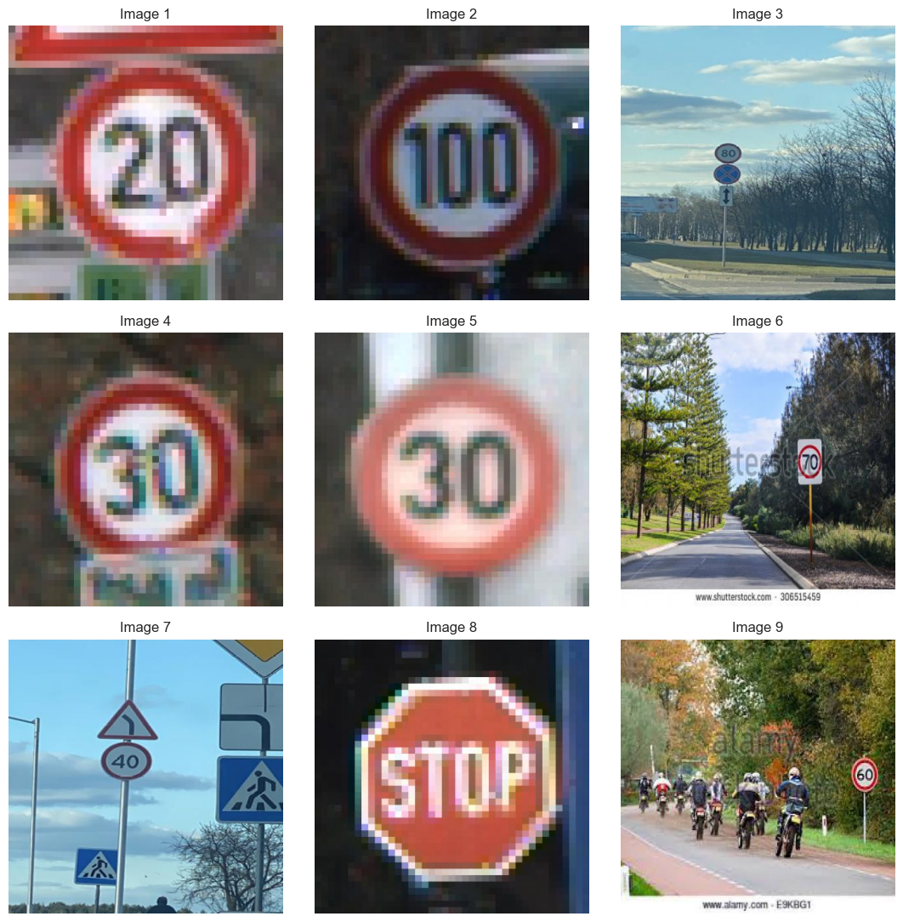

**FIGURE**: Displaying random images

**Outputs and Results**

**Visual Outputs:**

Image Visualization: The outputs from display functions offer a glimpse into how traffic signs appear under different conditions within the dataset, serving as a qualitative validation of data diversity.

Detection Results: The model outputs images with annotated predictions, showing bounding boxes and class labels on detected traffic signs. These visual results are instrumental in demonstrating the model's detection capabilities.

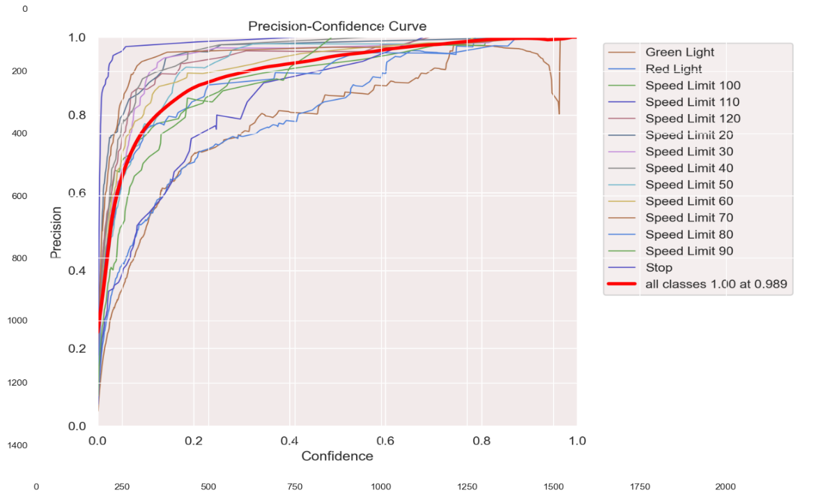

**FIGURE**: Precision-confidence curve

The Precision-Recall curve (P-R curve) is a graphical representation of the precision and recall for different threshold values. Precision is the ratio of true positive predictions to the total number of positive predictions (true positives + false positives). It measures the accuracy of positive predictions. Recall, also known as sensitivity, is the ratio of true positive predictions to the total number of actual positives (true positives + false negatives). It measures the ability of the model to find all the positive samples.

The curve illustrates how precision and recall vary with different thresholds. Generally, a higher area under the curve (AUC) indicates better performance of the model in terms of both precision and recall.

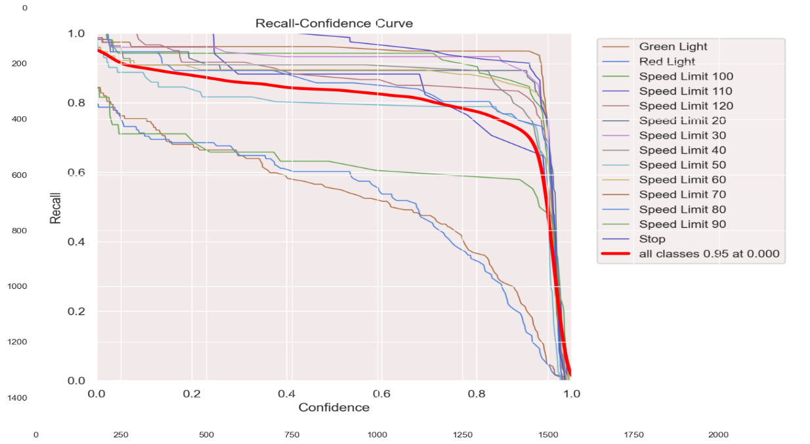

**FIGURE:** Recall-confidence curve

Similar to the Precision-Recall curve, the Recall curve (R curve) depicts the relationship between recall and different threshold values. Recall, as described earlier, measures the ability of the model to find all the positive samples. The curve shows how recall changes as the threshold for classifying positive predictions varies. Like the P-R curve, a higher AUC indicates better performance in terms of recall.

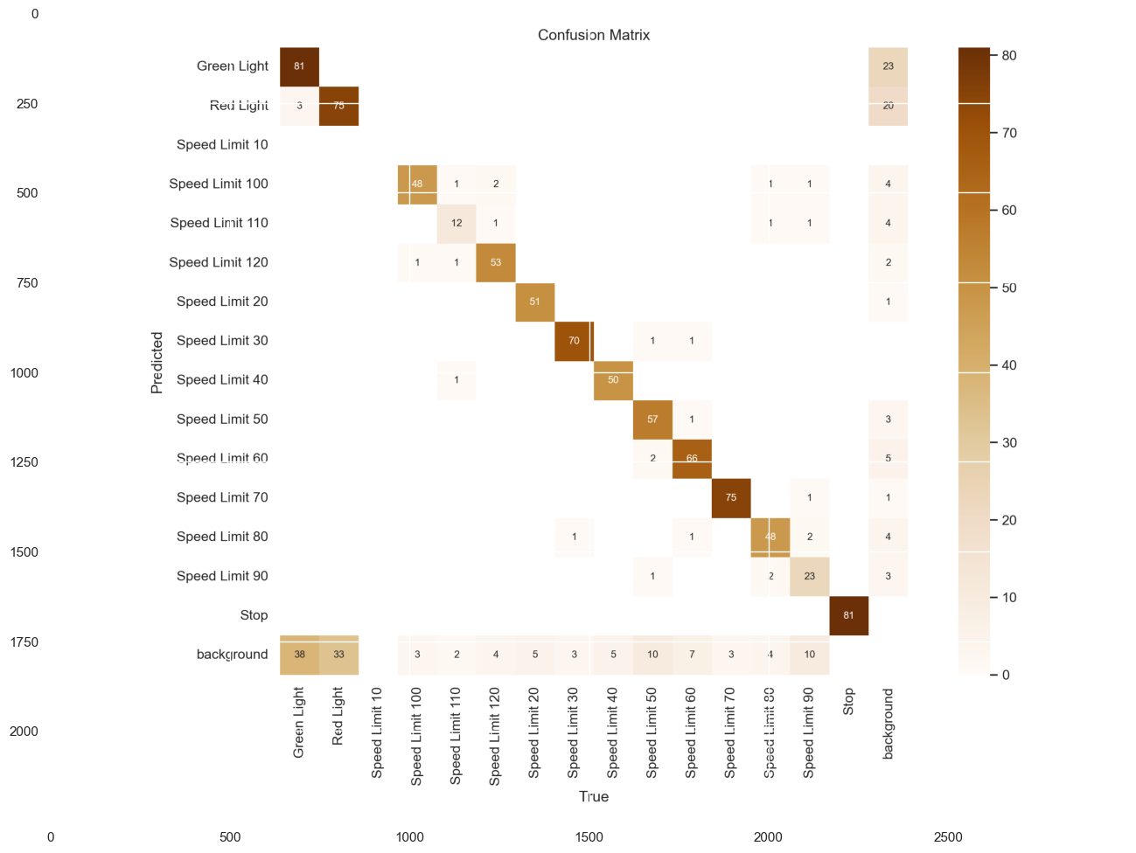

**FIGURE**: Confusion matrix

A confusion matrix is a table that is often used to describe the performance of a classification model on a set of test data for which the true values are known. It compares the predicted classes with the actual classes in a tabular format. The confusion matrix provides insight into the performance of the model across different classes. It helps in identifying where the model is making errors and which classes are being confused with others. From the confusion matrix, various performance metrics such as accuracy, precision, recall, and F1-score can be calculated.

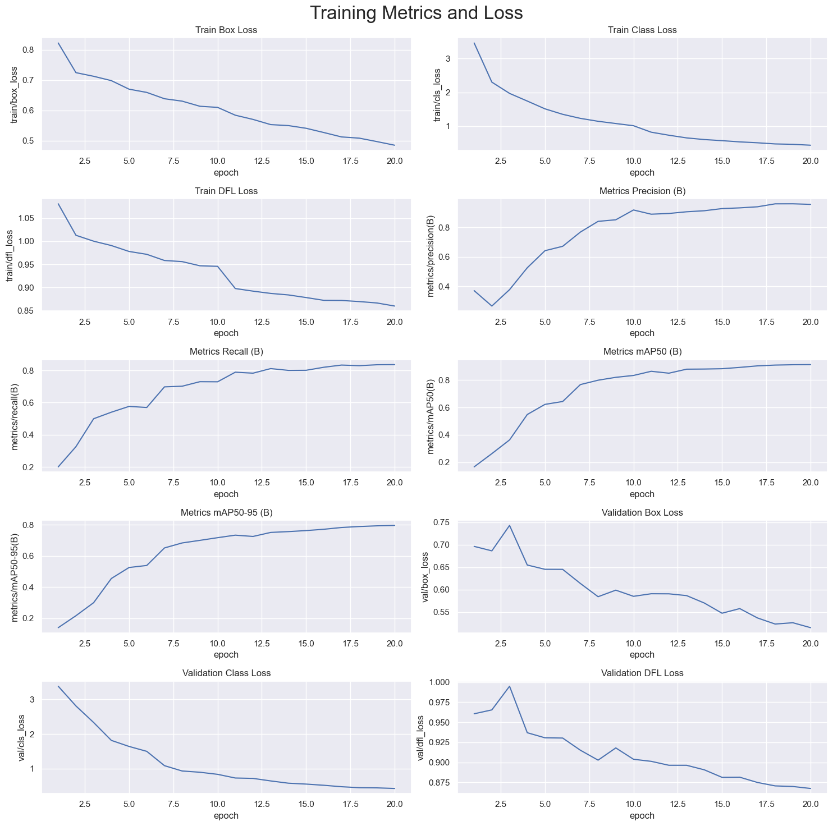

**FIGURE:** Training metrics and loss

In the process of training a model for object detection or a similar task, tracking various metrics and loss values is crucial to understanding the model's performance and behavior over time. The code snippet provided orchestrates the visualization of these metrics and losses across epochs, offering valuable insights into the training process.

The plotted metrics include key indicators such as bounding box loss, classification loss, precision, recall, and mean Average Precision (mAP) across different epochs. Each subplot within the visualization represents one of these metrics, with the x-axis denoting the epoch number and the y-axis representing the corresponding metric or loss value.

By examining these plots, one can discern patterns and trends in the model's learning process. For instance, a consistent decrease in loss values over epochs suggests that the model is improving in its predictive capabilities. Similarly, observing fluctuations or plateaus in precision, recall, or mAP values can provide insights into the model's ability to accurately detect and classify objects.

**Quantitative Metrics:**

Performance Evaluation: Key metrics such as precision, recall, mAP, and IoU are computed to quantitatively assess the model's performance. These metrics provide a detailed understanding of the model's effectiveness:

1. Precision measures the accuracy of the positive predictions.
2. Recall indicates how well the model can identify all relevant instances.
3. mAP offers an average precision across different recall levels, providing an overall effectiveness score.
4. IoU assesses the accuracy of object localization.

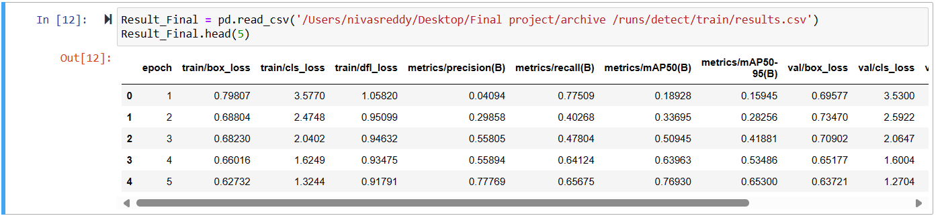

**FIGURE**: Displaying the sample code for the results

**Model Validation:**

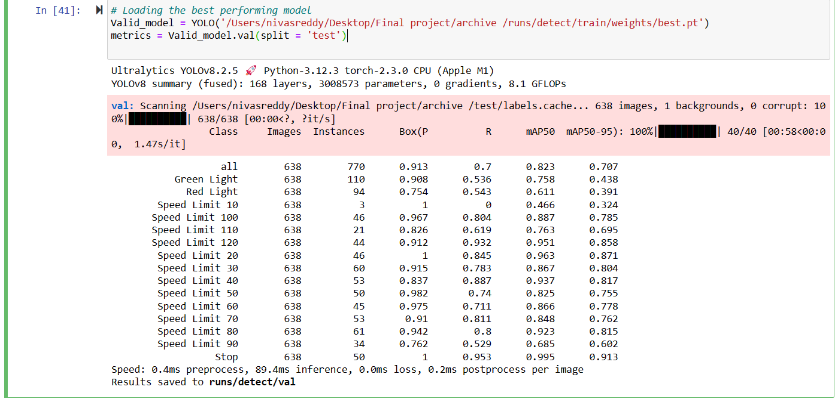

**FIGURE:** Model validation

These metrics provide valuable insights into the model's performance across different classes, highlighting its strengths and weaknesses. For example, the model achieves high precision for certain classes like 'Speed Limit 10' and 'Stop', indicating few false positive detections. However, it may struggle with recall for classes like 'Green Light' and 'Red Light', suggesting missed detections.

Additionally, the reported inference times give an idea of the computational efficiency of the model during inference, with breakdowns for preprocessing, inference, loss calculation, and postprocessing times per image.

**Evaluation Metrics:**

The model's performance is assessed using precision, recall, and mean Average Precision (mAP) metrics, providing insights into its ability to accurately detect and classify objects.

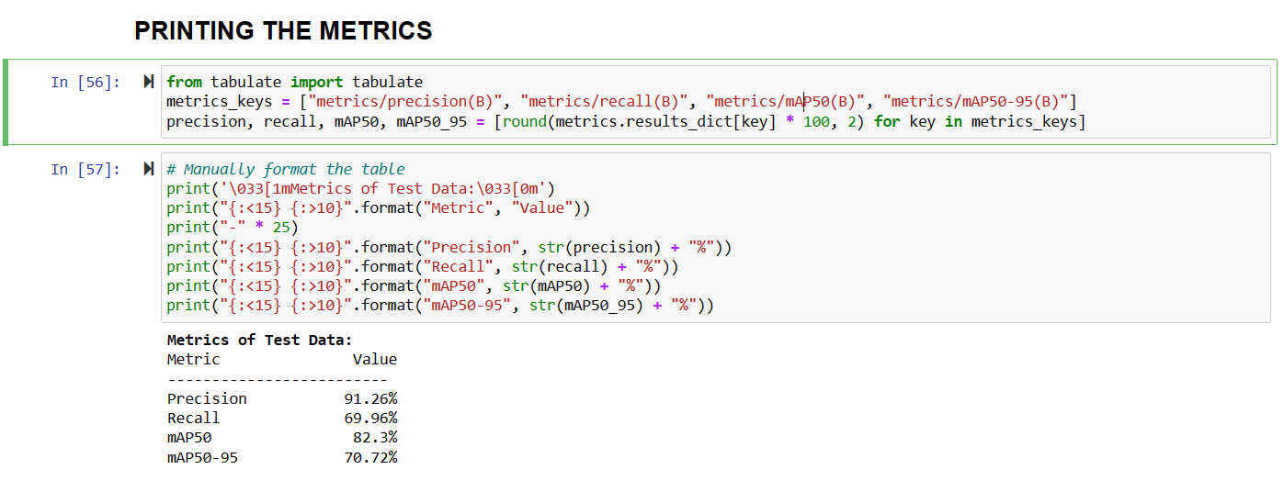

**FIGURE:** Evaluation metrics

**Precision**: Precision gauges how well the model predicts favorable outcomes. The model's precision in this evaluation was 91.26%, meaning that 91.26% of the items the model observed were properly classified.   
  
**Recall**: The model's recall, sometimes referred to as sensitivity, gauges its accuracy in identifying every positive case. With a recall of 69.96%, the model was able to identify 69.96% of all positive instances found in the test dataset.   
  
**mAP50**: A popular statistic for assessing object detection models is the mean Average Precision (mAP) at an Intersection over Union (IoU) threshold of 0.5. Considering detections with an IoU of 0.5 or higher, the model's mAP50 score of 82.3% indicates the average precision across all classes.

**mAP50-95**: mAP spanning a variety of IoU thresholds (often between 0.5 and 0.95) offers a more thorough evaluation of the model's performance at different detection accuracy levels. With a mAP50-95 score of 70.72%, the model demonstrated overall effectiveness across various IoU thresholds.   
  
In conclusion, the high precision and mAP scores of the object detection model show that it performs effectively in accurately detecting and classifying items, according to the evaluation criteria. Recall might be improved, though, meaning that certain instances of objects in the test dataset may be unnoticed by the model. The model's performance may be improved with more optimization and fine-tuning, resulting in more reliable and accurate object identification capabilities.

**Validating The Final Model**:

The results of running inference on a set of random images using a trained object detection model. The model's performance is evaluated in terms of detection speed and accuracy across various classes of objects.

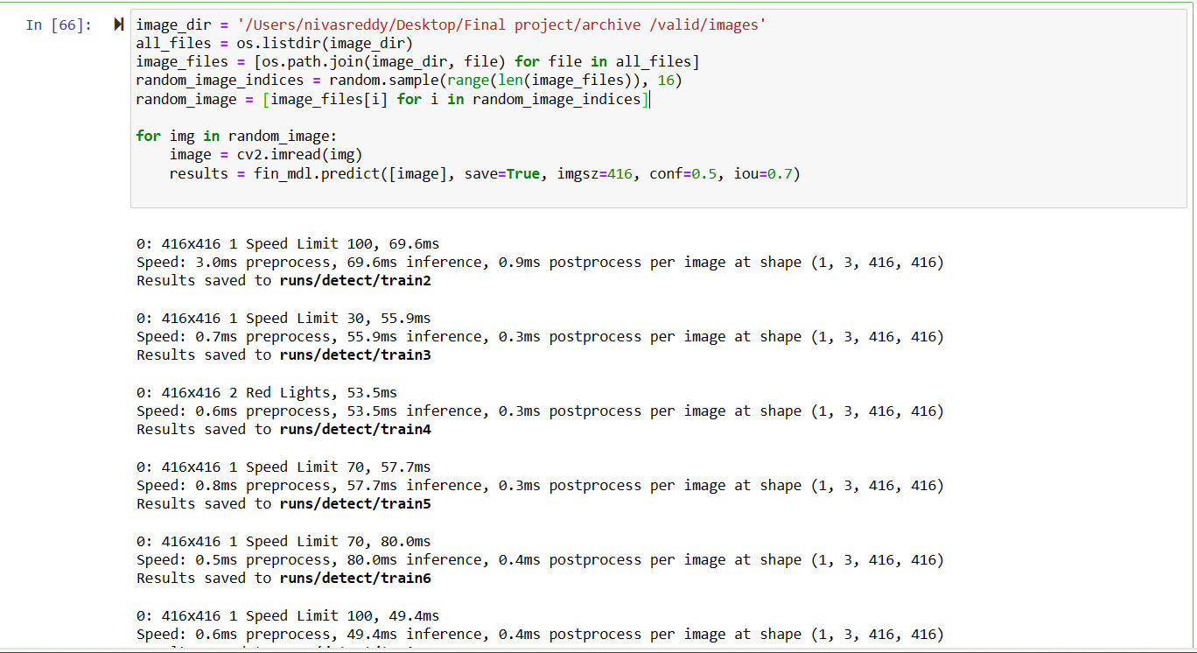

**FIGURE**: Validating the model

The model for object detection exhibits strong performance in precisely identifying and categorizing things belonging to different classes. The average detection speed varies between 45 and 80 ms per image, depending on the complexity of the object detection tasks. The model demonstrates its efficacy in real-world circumstances by accurately identifying a wide variety of items, such as stop signs, traffic lights, and speed limit signs.

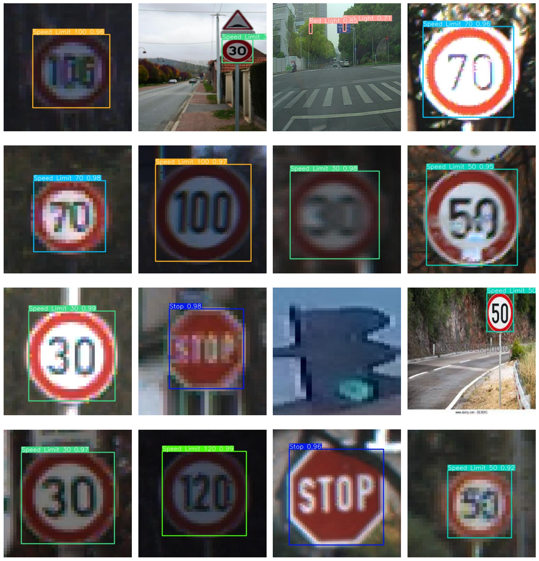

**FIGURE**: Final output after validating and testing the dataset

**Model Exporting:**

**ONNX Export:** Converting the trained YOLOv8 model into ONNX format facilitates model deployment across various platforms, ensuring that the model's utility is not confined to a single ecosystem but can be extended to multiple deployment environments. This step is crucial for integrating the model into real-world applications where different technologies might be used.

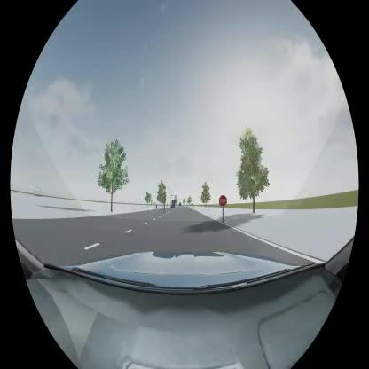

**FIGURE:** Sample video before training the yolo model

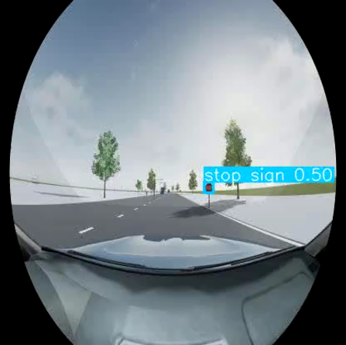

**FIGURE**: Sample video after training the yolo model

**CONCLUSION**:

This project successfully implemented the YOLOv8 algorithm for Traffic Sign Recognition (TSR), a critical advancement for autonomous driving systems and Advanced Driver-Assistance Systems (ADAS). By leveraging a robust dataset of diverse traffic signs, the model demonstrated high efficiency in real-time object detection, providing accurate recognition across varied environmental conditions. The utilization of YOLOv8, noted for its enhanced feature fusion and spatial attention mechanisms, has significantly improved the detection accuracy and speed, making it a formidable tool in the computer vision domain. The findings from this project underscore the potential of deep learning technologies in enhancing roadway safety and navigation. The precision, recall, and mAP metrics derived from rigorous testing validate the model’s effectiveness in recognizing and classifying traffic signs, which is crucial for the real-time decision-making required in autonomous vehicles. Additionally, the project explored the potential for future enhancements such as model optimization for edge deployment, integration with other sensor data, and real-time adaptive learning capabilities.

In total, the successful application of the YOLOv8 model in traffic sign detection not only marks a significant step forward in the field of computer vision but also opens up numerous possibilities for future research and application. This project lays a solid foundation for further innovations that could lead to more sophisticated, reliable, and efficient autonomous driving technologies, ultimately driving us towards a safer, smarter driving environment.

**REFERENCES:**

1. *Detection of traffic signs in real-world images: The German traffic sign detection benchmark*. (2013, August 1). IEEE Conference Publication | IEEE Xplore. <https://ieeexplore.ieee.org/abstract/document/6706807>
2. Flores-Calero, M., Astudillo, C., Guevara, D., Maza, J., Lita, B. S., Defaz, B., Ante, J. S., Zabala-Blanco, D., & Armingol, J. M. (2024). Traffic Sign Detection and Recognition using YOLO Object Detection Algorithm: A Systematic review. *Mathematics*, *12*(2), 297. <https://doi.org/10.3390/math12020297>
3. Ahmed, S. K., Mohamed, M. G., Abdulqadir, S. O., El–Kader, R. G. A., El‐Shall, N. A., Chandran, D., Rehman, M. E. U., & Dhama, K. (2023). Road traffic accidental injuries and deaths: A neglected global health issue. *Health Science Reports*, *6*(5). <https://doi.org/10.1002/hsr2.1240>
4. Mehra, A. (2023, October 8). *Understanding YOLOv8 Architecture, Applications & Features*. Labellerr. <https://www.labellerr.com/blog/understanding-yolov8-architecture-applications-features/>
5. Boesch, G. (2024, March 27). *A guide to YOLOV8 in 2024*. viso.ai. <https://viso.ai/deep-learning/yolov8-guide/>